# CS 340 README Template

## About the Project/Project Title

Grazioso Salvare is an international rescue-animal training group. The company Global Rain develops this group. They search for dogs that could have a future as search and rescue companions.

In this project, we take existing data from 5 nonprofit animal shelters around the Austin, Texas region. This will allow Grazioso Salvare to identify candidates for their program. Some of the things they will be looking for are; breed, age, and any characteristics the dog might have to be a good fit. Some examples of rescue training might be for water, mountains, disasters, or scent tracking. Their main focus is to search for dogs that are preferably no more than two years old.

## Motivation

## This project is intended to address the critical need to search for dogs for search and rescue. As disasters have become more prevalent in the world, it’s imperative for Salvare to find candidates who can be trained to be successful. They also want to give these candidates a new lease on life instead of living in a cell.

## Getting Started

*This is an example of how you may give instructions on setting up your project locally: “To get a local copy up and running, follow these simple example steps.”*

1. Install MongoDB on your computer.
2. Create a database in Mongo for the Austin Animal Shelters.
3. Create user credentials for read/write privileges.
4. Import the data from the shelter's database.

## Installation

In order for this project to function correctly, users will need to have the latest Python and MongoDB installed. The latest versions are:

Python 3.12

MongoDB 8.0 (2024)

Must have at least a 500 Mbps internet speed

## Usage

*Use this space to show useful examples of how your project works and how it can be used. Be sure to include examples of your code, tests, and screenshots.*

### Code Example

Create the Python script py file first. This file executes shell commands.

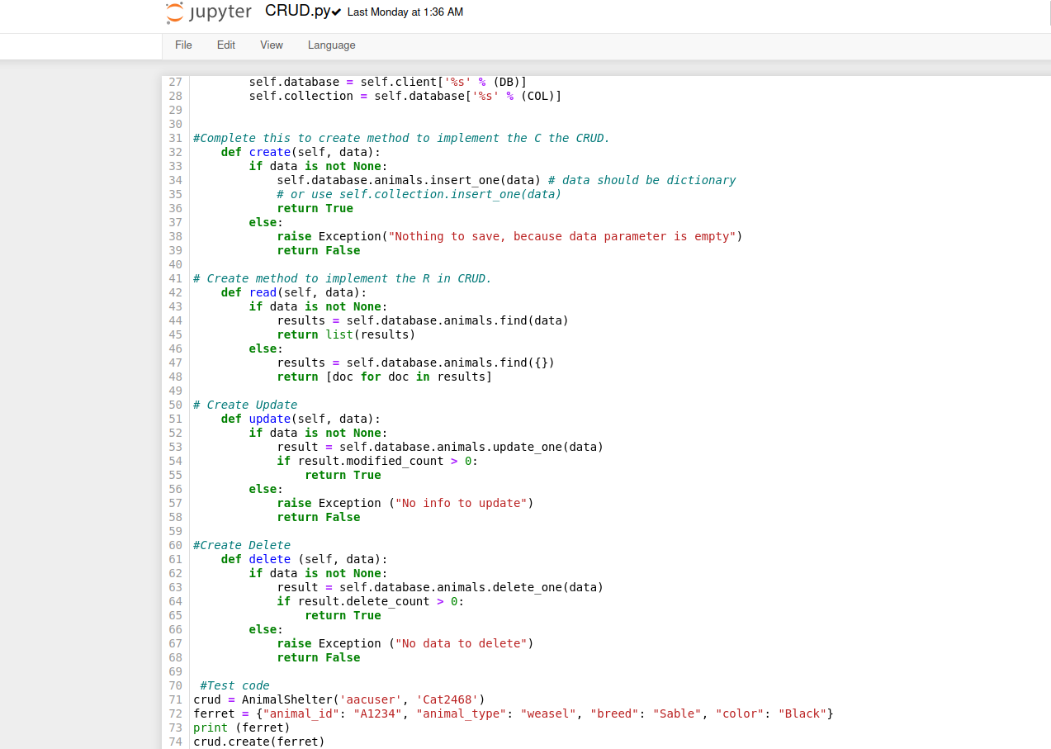

Tests

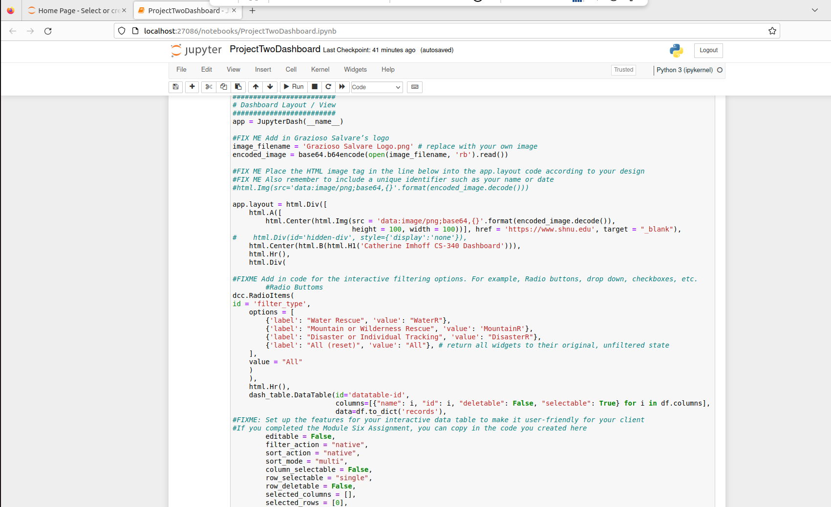

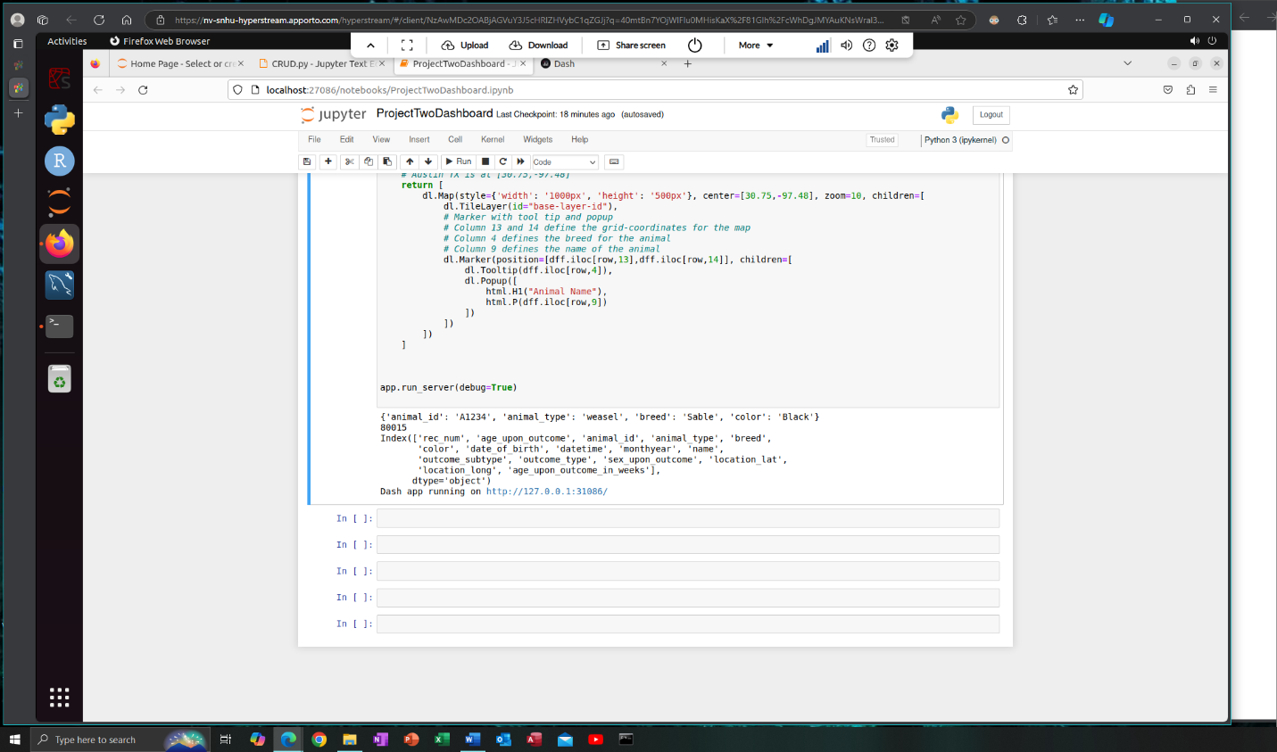

### After running the code, an http address with show. Click on that to show your dashboard.

### Wait for everything to load.

### Screenshots

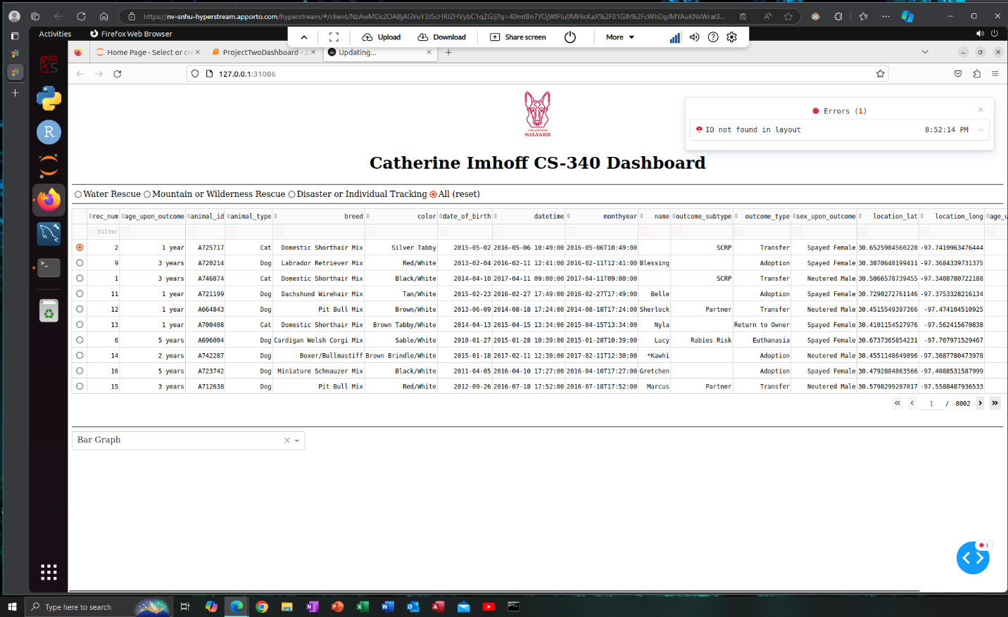

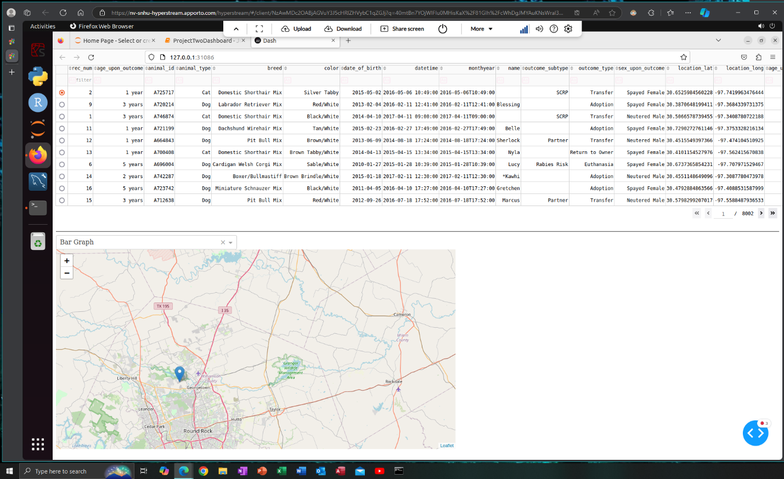

## Once completely loaded, a map of the coordinates coded will show the location.

## Contact

Catherine Imhoff